SWANSEA UNIVERSITY CHEMICAL WASTE
Faculty |  | Contact name
Building |  | Date
Substance/ Contents |  | 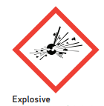  Hazards: |  | 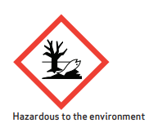 |  | 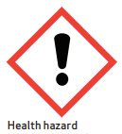
 |  | 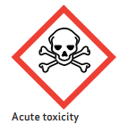 |  | 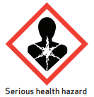 |  | 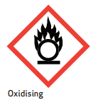
 |  | 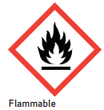 |  | 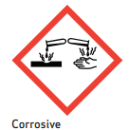
Lab/ room number |  | ID Quartzy
Chemical Waste Labels – how to adjust size

To reduce the label size, copy the whole table (right click on ‘adjust’ icon in top left hand corner of table and copy), ‘paste special’ – picture enhanced metafile, then re-size (move re-size cursor or click on table, go to format tab and adjust height and width)

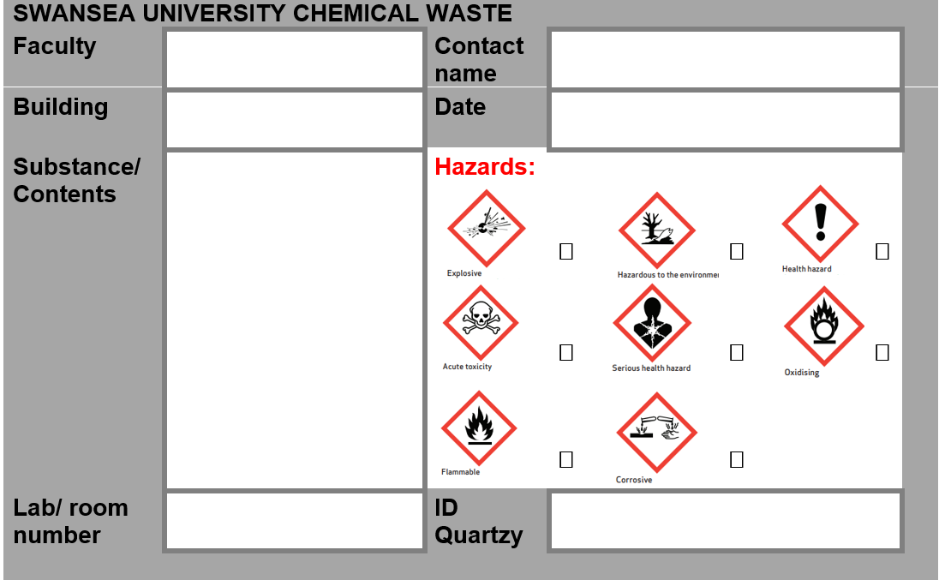

The larger label can be filled in electronically with specific chemical and contact details before then re-sizing, this will aid fitting the information on. However, please ensure once re-sized the information is still legible.

If a legible label is still too big for the container, affix with tape, although please make sure this is done in a way that does not cause the container to fall over / do not lay a container on its side.

