SWANSEA UNIVERSITY OIL / COOLANT / LUBRICANT WASTE LABEL
Faculty |  | Contact name
Building |  | Date
Substance/ Contents | OIL / COOLANT / LUBRICANT NAME | Hazards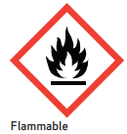 |  | 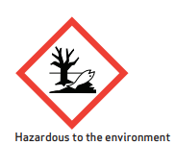 |  | 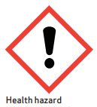
Lab/ room number

